Final Project Report

Research Submission and Evaluation System for University



Project Supervisor

Muhammad Saeed Amjad

Submitted By

BC210409630

Software Projects & Research Section,
Department of Computer Sciences,
Virtual University of Pakistan


CERTIFICATE

This is to certify that Ayesha Arbi (BC210409630) have worked on and completed their Software Project at Software & Research Projects Section, Department of Computer Sciences, Virtual University of Pakistan in partial fulfillment of the requirement for the degree of BS in Computer Sciences under my guidance and supervision.

In our opinion, it is satisfactory and up to the mark and therefore fulfills the requirements of BS in Computer Sciences.

Supervisor / Internal Examiner

Muhammad Saeed Amjad
Supervisor,
Software Projects & Research Section,
Department of Computer Sciences
Virtual University of Pakistan

___________________
(Signature)

External Examiner/Subject Specialist
<<External Supervisor Name>>

___________________
(Signature)

Accepted By:

_____________
(For office use)

EXORDIUM

In the name of Allah, the Compassionate, the Merciful.

Praise be to Allah, Lord of Creation,
The Compassionate, the Merciful,
King of Judgment-day!

You alone we worship, and to You alone we pray for help,
Guide us to the straight path

The path of those who You have favored,

Not of those who have incurred Your wrath,
Nor of those who have gone astray.

DEDICATION



IN THE NAME OF ALLAH THE MOST BENIFICIENT THE MERCIFUL

I dedicate this Project to my beloved
Father & Teachers
And
To the Loving memory of my Mother
And also
To my brothers & sisters.
You have successfully made me the person I am becoming
You will always be remembered.

ACKNOWLEDGEMENT

Foremost, I am highly grateful to Allah for His blessing that continue to flow into my life, and because of You, I made this through against all odds.

With a great pleasure I would like to acknowledge the support, assistances and contribution made by individuals from the beginning of the Project, providing me access, data and information, to the writing process until the completion of this project.

First of all, I want to give thanks to our project supervisors Asif Hussain for the access and assistance in order to make my project possible.

Second I would like to thank all the Mater program staff, thank you all for the assistance and constructive discussions we had during the entire courses

PREFACE

This project report has been prepared in fulfillment of the requirements for the BS in Computer Science.

For preparing of the project report, I have closely studied the Research Submission and Evaluation System for University of certain compounds to get the knowledge of the data requirements that will be used successfully to protect any entrance breaches.

I have also studied the software that was required for this project coding like, PHP and databases.

This project started with to final coding I which have given me the ability to understand the concept of programming and move me forward smoothly.

I am very thankful to my supervisors who have helped me to complete this project and I really appreciate all his efforts and support.

I am also very thankful to Virtual University, Pakistan and all the staff.

TABLE OF CONTENTS

Chapter No. 1
Gathering & Analyzing Info 9

1.1 Introduction: 10
1.2 Purpose: 10
1.3 Scope of Project: 10
1.4 Definitions, Acronyms and Abbreviations 11
1.5 Project Requirements 11
1.5.1 Functional Requirements: 11
1.5.2 Non-Functional Requirements: 11
1.6 Use Cases and Usage Scenarios: 14
1.6.1 Use Case Diagram: 14
1.6.2 Usage Scenarios: 15
1.7 Development Methodology: 18
1.7.1 Chosen Methodology: 18
1.7.2 Reasons for Chosen Methodology: 18
1.7.3 Work Plan (Gantt Chart): 21
1.7.4 Project Schedule (Submission Calendar): 22

Chapter No. 2
Designing the project 23

2.1 Introduction: 24
2.2 Purpose: 24
2.3 Scope: 24
2.4 Definitions, Acronyms and Abbreviations: 24
2.5 Architectural Representation (Architecture Diagram) 24
2.6 Dynamic Model: Sequence Diagrams: 26
2.7 Object Model/Logical Model: Class Diagram: 31
2.8 Database Model (Database Diagram): 31
2.9 Graphical User Interfaces: 32

Chapter 3
Development 35

3.1 Development plan (Architecture Diagram) 36

Chapter 1

Gathering & Analyzing Info

Introduction:

The first draft of the Software Requirements Specification (SRS) document has been prepared for the project. This document highlights the system's primary goals and scope. It contains: Scope, Use Case Diagram, Usage Scenarios,

Chosen Methodology, Gantt Chart

Purpose:

The platform connects book lovers, helps build a community, and supports sustainability by encouraging the reuse of books. It is designed to be easy to use and accessible on devices like computers, tablets, and smartphones

Scope of Project:

This system supports student registration, research paper submission with metadata, faculty evaluations with feedback, and administrative monitoring. It includes document versioning, email notifications, role-based access, and public access to accepted and published papers. The system also allows searching, filtering, and generating detailed reports, all within a responsive and user-friendly interface accessible across multiple devices.

Definitions, Acronyms and Abbreviations

• HTML (Hyper Text Markup Language)
• CSS (Cascade Styling Sheet
• DBMS (Database Management System)
• SQL (Structured Query Language)

Project Requirements

Functional Requirements:

- User Registration and Authentication
  - Student Registration:
    - Students must be able to create an account using their university email addresses and personal details.
  - Faculty Member / Supervisor Registration:
    - Faculty Members and Supervisors can register to the system by providing necessary details.
- Role-Based Access Control
  - The system will have different roles with varied access levels:
    - Students:
      - Submit research papers
      - View evaluations/feedback
      - Download reviewed/commented files
    - Faculty Members / Supervisors:
      - Create research assignments and set due dates
      - Review and evaluate submissions
      - Upload reviewed/commented files
      - Provide feedback and rate research papers (star rating)
      - Publish accepted research papers
    - Admin:
      - Manage user roles (accept/reject registrations)
      - Monitor submissions and tracking
      - Generate reports
- Research Paper Submission
  - Students can submit research papers (PDF or MS Word format) against the relevant research assignment.
  - Interactive interface for entering metadata:
    - Student ID
    - Study Program Enrolled
    - Paper Title
    - Abstract
    - Keywords
    - Category/Domain
  - Students can select the relevant faculty member/supervisor from a list.
  - Students can check the status of their submissions.
  - Submissions are deadline-based; late submissions are not allowed.
- Research Paper Evaluation
  - Faculty/Supervisors evaluate papers using predefined criteria:
    - Paper structure
    - Clarity
    - Originality
    - Domain relevance
    - Novelty
    - Quality of research
  - Evaluation outcomes can be:
    - Accepted
    - Rejected (with reason)
    - Needs Improvement
    - Accepted and Published
  - Faculty can upload commented files and provide additional feedback.
  - Only “Accepted and Published” papers are publicly accessible.
  - Faculty can view past submissions and evaluations.
- Document Versioning and Update
  - Students can update submitted research papers.
  - System maintains logs of all versions.
- Notifications
  - Students:
    - On submission
    - After evaluation
    - When feedback is available
  - Faculty/Supervisors:
    - When new submissions are received
  - Admin:
    - On pending evaluations or issues
- Search and Filter Submissions
  - For “Accepted and Published” papers, users can search by:
    - Student ID
    - Study Program
    - Category
    - Date
    - Author
- Report Generation
  - Admin:
    - Submission statistics
    - Evaluation progress
    - List of published papers
  - Faculty/Supervisors:
    - Reports based on their students' evaluations
- Admin Panel
  - Manage users (add/edit/delete)
  - Monitor submission statuses
  - Track evaluation progress
  - Ensure timely feedback
- Responsive and User-Friendly Design
  - Accessible across devices (desktop, tablet, mobile)
  - Intuitive and user-friendly interface

2.2 Non-Functional Requirements:

Non-functional requirements are the criteria that define how a system should behave, rather than what it is supposed to do. Unlike functional requirements, which describe specific system functions, non-functional requirements define aspects like performance, security, usability, reliability, and scalability.

- Usability
The system must provide a user-friendly and intuitive interface for students, faculty, and admin users. It should be easy to navigate with minimal training.
- Performance
The system should respond quickly to user actions, ensuring smooth operations even under heavy usage, especially during submission and evaluation periods.
- Scalability
The system should be scalable to accommodate a growing number of users, research papers, and roles without performance degradation.
- Reliability
The system must ensure high availability and consistent functionality to avoid disruptions during critical academic activities like paper submission or evaluation.
- Security
Strong authentication, role-based access control, and secure file uploads should be implemented to protect sensitive data and prevent unauthorized access.
- Maintainability
The codebase and database structure should be modular and well-documented to allow easy updates, debugging, and future enhancements.
- Compatibility
The system must be compatible across various browsers (Chrome, Firefox, Safari, etc.) and devices (desktop, tablet, mobile).
- Accessibility
The system should comply with accessibility standards (e.g., WCAG) to support users with disabilities, including screen reader compatibility and keyboard navigation.
- Data Privacy
Personal and academic data must be handled in compliance with privacy laws and regulations. Data should be stored securely and only accessible to authorized users

Use Cases and Usage Scenarios:

Use Case Diagram:
A Use Case Diagram visually represents the interactions between users (actors) and a system, highlighting the system's functionalities (use cases) within its defined boundaries. It shows how actors interact with specific use cases through associations and may include relationships like "include" for mandatory actions and "extend" for optional behaviors. This diagram is used to capture system requirements, communicate functionality to stakeholders, and guide the system's design by focusing on what the system should do, not how it does it.

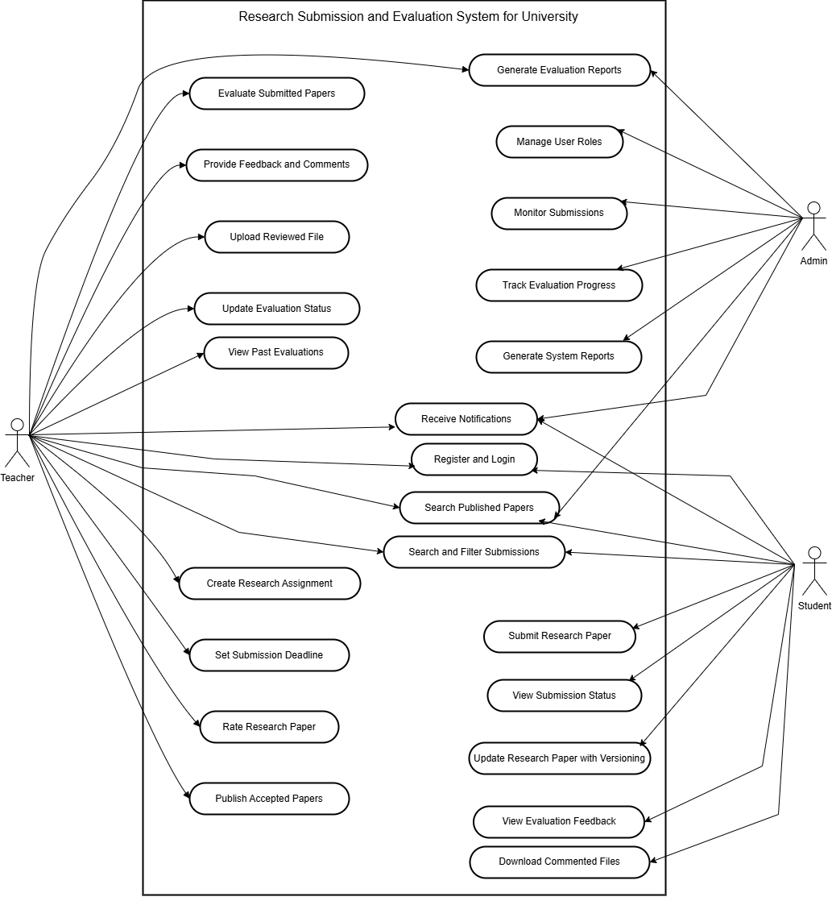

Usage Scenarios:
Usage scenarios outline how a product, service, or technology is applied to meet specific needs or solve problems in real-world contexts. They highlight key users, their goals, and the solution’s impact.

Use Case ID | UC001
Use Case Title | Student Registration
Actions | - Open registration form  - Enter university email and personal details  - Submit the registration form  - Receive verification email  - Click the verification link
Description | Enables students to register using their university email and personal details
Alternative Paths | - Email already registered  - Verification fails
Pre and Post Conditions | Pre: Not registered Post: Pending approval
Author | BC210409630
Exceptions | Invalid email, missing fields, server down
Use Case ID | UC002
Use Case Title | Faculty/Supervisor Registration
Actions | - Open registration form  - Enter details  - Submit registration form  - Wait for admin approval
Description | Faculty/supervisors register to evaluate papers
Alternative Paths | Already registered faculty gets an error
Pre and Post Conditions | Pre: Not in system Post: Pending approval
Author | BC210409630
Exceptions | Invalid input, duplicate, approval error
Use Case ID | UC003
Use Case Title | User Login
Actions | - Go to login page - Enter username/password - Click login - System verifies credentials - Redirect to dashboard
Description | Authenticates users based on roles
Alternative Paths | - Incorrect credentials  - Password recovery
Pre and Post Conditions | Pre: Account exists Post: Role dashboard
Author | BC210409630
Exceptions | Wrong credentials, inactive account
Use Case ID | UC004
Use Case Title | Role-Based Access
Actions | - Login to system  - System identifies role  - Display role-based dashboard
Description | Shows functionalities relevant to user roles
Alternative Paths | NA
Pre and Post Conditions | Pre: Logged in Post: Role-based UI
Author | BC210409630
Exceptions | Role mapping issue, unauthorized access
Use Case ID | UC005
Use Case Title | Submit Research Paper
Actions | - Login as student  - Open submission section  - Upload file  - Fill metadata  - Select faculty  - Submit  - Email sent to faculty
Description | Students submit research before deadline
Alternative Paths | Submission not allowed if deadline passed
Pre and Post Conditions | Pre: Assignment available Post: Submitted
Author | BC210409630
Exceptions | Invalid file, submission closed
Use Case ID | UC006
Use Case Title | Evaluate Research Paper
Actions | - Login as faculty  - Open assigned submissions  - Review paper  - Add feedback  - Rate and set status  - Submit evaluation
Description | Faculty evaluate papers using criteria
Alternative Paths | Reject if plagiarized or off-topic
Pre and Post Conditions | Pre: Submission exists Post: Evaluated
Author | BC210409630
Exceptions | Missing criteria, save error
Use Case ID | UC007
Use Case Title | Upload Reviewed Document
Actions | - Login as faculty - Open evaluated paper - Upload reviewed file - Confirm upload
Description | Upload reviewed/corrected file after evaluation
Alternative Paths | No upload if status is not Rejected/Needs Improvement
Pre and Post Conditions | Pre: Evaluation complete Post: File uploaded
Author | BC210409630
Exceptions | Invalid file, upload failure
Use Case ID | UC008
Use Case Title | Publish Research Paper
Actions | - Login as faculty/admin  - Open evaluated paper  - Set status to Accepted  - Click Publish
Description | Publishes papers marked as Accepted
Alternative Paths | Only Accepted papers can be published
Pre and Post Conditions | Pre: Accepted Post: Public paper
Author | BC210409630
Exceptions | Wrong status, upload issue
Use Case ID | UC009
Use Case Title | Update Submission
Actions | - Login as student  - Open submission  - Upload new version  - System logs old version  - Submit updated file
Description | Upload new version of submission
Alternative Paths | Previous versions visible to admin
Pre and Post Conditions | Pre: Submission exists Post: Updated
Author | BC210409630
Exceptions | File format error, storage issue
Use Case ID | UC010
Use Case Title | Email Notifications
Actions | - Event is triggered  - System generates email  - Email sent to user
Description | Sends email for submissions, feedback, evaluations
Alternative Paths | NA
Pre and Post Conditions | Pre: Event triggered Post: Email sent
Author | BC210409630
Exceptions | Email server failure
Use Case ID | UC011
Use Case Title | Search Submissions
Actions | - Go to search page  - Enter filters (keywords, author, etc.)  - Submit search  - View results
Description | Search published papers by filters
Alternative Paths | NA
Pre and Post Conditions | Pre: Published papers Post: Results
Author | BC210409630
Exceptions | No results, search timeout
Use Case ID | UC012
Use Case Title | Generate Reports
Actions | - Login as admin/faculty  - Select report type  - Choose filters  - Generate report  - Download report
Description | Generate stats reports in PDF/Excel
Alternative Paths | NA
Pre and Post Conditions | Pre: Data exists Post: Report file
Author | BC210409630
Exceptions | No permission, data error
Use Case ID | UC013
Use Case Title | Admin Panel Access
Actions | - Login as admin  - Access dashboard  - Manage users  - Review submissions  - Check feedback
Description | Admin manages users, submissions, feedback
Alternative Paths | NA
Pre and Post Conditions | Pre: Admin logged in Post: Actions complete
Author | BC210409630
Exceptions | System crash, access denied
Use Case ID | UC014
Use Case Title | Track Evaluation Progress
Actions | - Login as admin/faculty  - View evaluation status  - Track pending evaluations  - Send reminders
Description | Monitor evaluation progress of papers
Alternative Paths | NA
Pre and Post Conditions | Pre: Evaluations pending Post: Status tracked
Author | BC210409630
Exceptions | Data missing, update failed
Use Case ID | UC015
Use Case Title | Download Reviewed Files
Actions | - Login as student  - Navigate to reviewed papers  - Click download  - Save file locally
Description | Students download reviewed file with feedback
Alternative Paths | If no file available, show message
Pre and Post Conditions | Pre: File available Post: File downloaded
Author | BC210409630
Exceptions | File missing, access denied

Adopted Methodology:

Let’s see what the word methodology really means.
The branch of philosophy that analyze the principles and procedures of inquiry in a particular discipline and here in software development, methodology is a predefined standard procedure to accomplish a development goal successfully. Software engineering discipline provides a number of methodologies for project management.

Existing Methodologies:

We have studied a number of methodologies in our Software Engineering-II course such as Build & Fix Model, Waterfall Model, Rapid Prototyping Model, Integrated Waterfall and Rapid Prototyping Model, Rapid Application Development Model, Synchronize & Stabilize Model and Spiral Model. Of course, there are many other models available in the market like Feature Driven Development, Extreme Programming (XP) Model, and Dynamic System Development Model and SCRUM etc.
Study shows that each methodology has its unique benefits and drawbacks.
Let’s have a close look on the prominent methodologies of the day.
Waterfall Model:

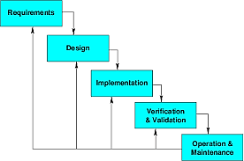
Model Description:

Owing to its cascaded design it is called waterfall model; it is also known as linear sequential model. A conventional waterfall model comprises of five stages: first one is Requirement Definition stage, second is System and Software Design, third is Implementation and Unit Testing, forth is Integration and System Testing and the last one is Operation and Maintenance. Practically, the proposed design flow of the waterfall model is rarely followed. In real projects errors and mistakes of any stage should be traced and report back to the source for necessary amendment and relevant documents should also be updated accordingly. This model is document driven so, it provides sufficient documentation and no stage is considered complete until the documentation of relevant stage is complete. In real life waterfall model-based projects, there exists a feedback loop from any stage to its previous stage. The down side of this model is its late feedback from the end user / customer which comes at the end of project and thus led to time and cost related problems in case of any incompliance, it may cause a threat for concern project.

Spiral Model
Block Diagram for Spiral Model:

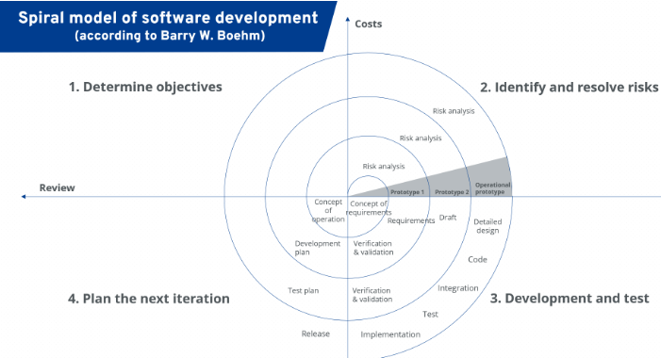

Model Description:

Spiral Model is developed by Barry Boehm and the central idea behind its design is to avert risk as there is always a risk factor in every software development project regarding time, cost and quality etc. This model continuously analyzes risk factors, involved in the project. The main strength of Spiral Model is that it is very sensitive to risk factor. In fact it is a combination of waterfall model plus risk analysis. Here each stage is preceded by identification of alternatives and concerning risk analysis and it is then followed by evaluation and planning for the next phase. If the encountered risks of any iteration cannot be resolved, the project is immediately terminated. There is no distinction between development and maintenance in this approach. It is suitable for only large scale projects. It is also applicable for internal or in house development. As we can see it has two dimensions, the cumulative cost to date, is represented by its radical dimension and progress is shown by its angular dimension.

VU Process Model:

Block Diagram For VU Process Model:
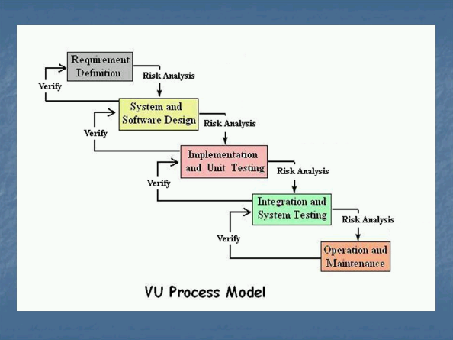

Model Description:

Virtual University of Pakistan suggests its final project students the V.U Process Model which is a combination of Spiral and Waterfall models therefore it combines the benefits of both the models i.e. Waterfall Methodology ensures and exercises strong documentation as it is a sequential and document driven methodology while Spiral Model enforce continuous risk analysis and search for alternatives. These facts make a winning combination when V.U Process Model is used in its true spirit.

Adopted Methodology

As per university guidance, adopted methodology is V.U Process Model. It has a number of salient features that direct the students to work in right direction and in the right way. It provides two strong frame works of product documentation and various risk factors analysis.

Reasons for choosing the Methodology

Combination of both Waterfall and Spiral model is called hybrid approach of system development that maximizes the quality of the system and minimizes the disadvantages and risks. VU process model has four phases which further divides the Waterfall processes. These processes are in iteration until system meets to the department’s requirement.

Work Plan (Gantt Chart):
The work plan is a document that consulting firms use to organize a project. It outlines the plan by which the company plans to complete a quality project within a given amount of time and in compliance with a set budget.
Gantt charts are useful tools for planning and scheduling projects. They allow you to assess how long a project should take, determine the resources needed and layout the order in which tasks need to be carried out. They are useful in managing the dependencies between tasks.
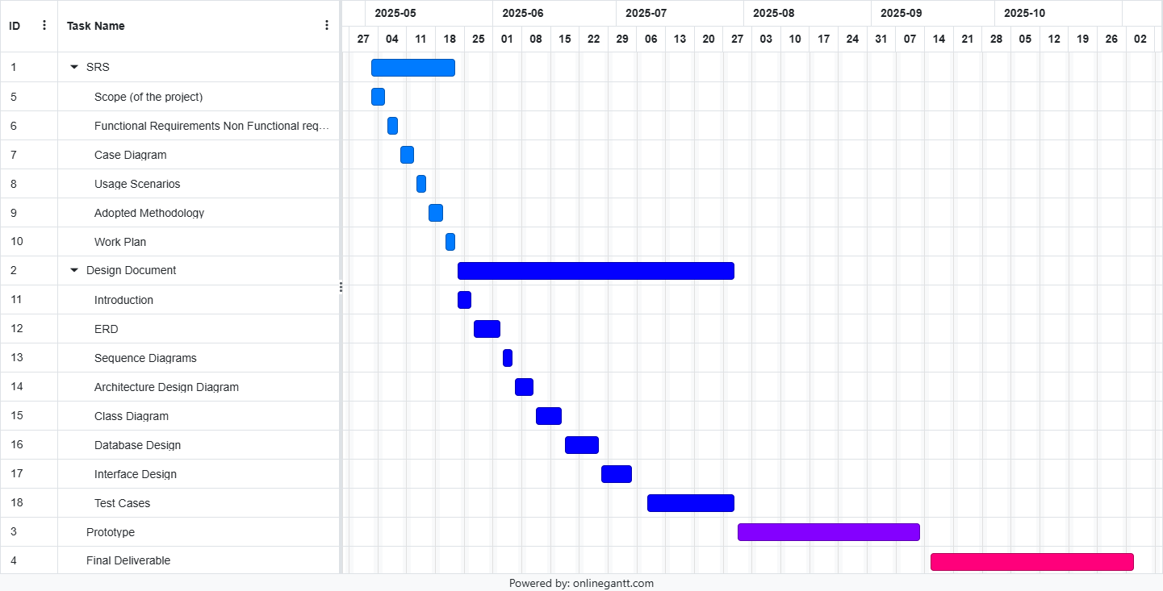

Project Schedule (Submission Calendar):

S No | Task | Start Date | End Date
01 | SRS | Fri 02 May, 2025 | Thu 22 May, 2025
02 | Design Document | Fri 23 May, 2025 | Tue 29 Jul, 2025
03 | Prototype Phase | Wed 30 Jul, 2025 | Fri 12 Sep, 2025
04 | Final Deliverable | Stat 13 Sep, 2025 | Mon 24 Nov, 2025

Chapter 2

Designing the project

Introduction:
The document provides documentation which will be used to aid in system development. The document provides the details of how the software should be built. The design document includes Entity Relationship Diagram (ERD), Sequence Diagrams, Architecture Design Diagrams, Class Diagram, Database Design, Interface design and Test Cases and other supporting requirement information.

Purpose:
The purpose of software design document is to provide a description of design of system fully enough to allow for software development to proceed with an understanding of what is to be built and how it is expected to build. The software design document provides information necessary to provide description of the details for the software and system to be built.

Scope:
The analysis and design phase in software development process is very important as it provide better management and understanding of the requirements. Additionally, system scope, verification and validation are done in analysis and design. Software quality assurance related planning is done in this phase of project.

Definitions, Acronyms and Abbreviations

• HTML (Hyper Text Markup Language)
• CSS (Cascade Styling Sheet)
• DBMS (Database Management System)
• SQL (Structured Query Language)

ERD
ERD is a diagram that shows the relationships between a group of entities stored in a database. In other words, the ER diagram helps to explain the logical structure of a database. ER diagrams consists of Entities, Attributes, and Relationships. ER diagrams have many shapes like: rectangle shape represent entities, ellipses shape define attributes, and diamond shape represent relationships

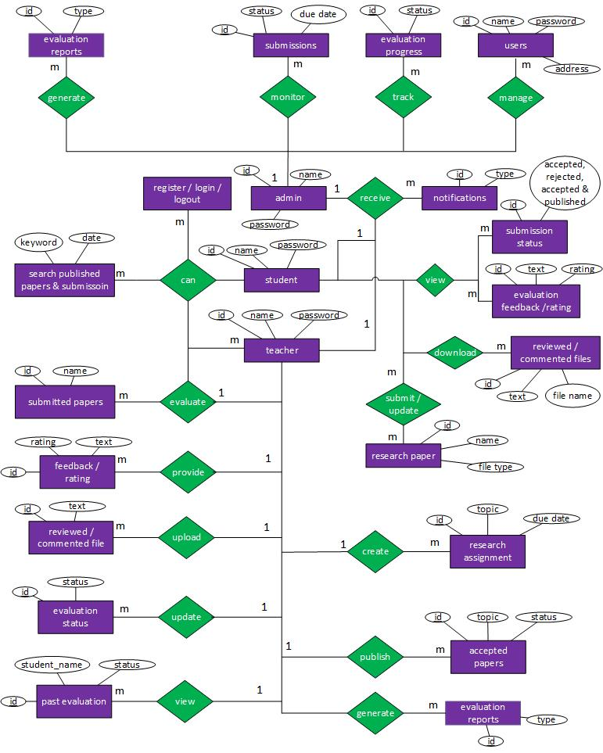

Architectural Representation (Architecture Diagram)
An architecture diagram is a visual representation of the components, relationships, and responsibilities within a software system. It shows the big picture of a software project and outlines the architecture that has been chosen.

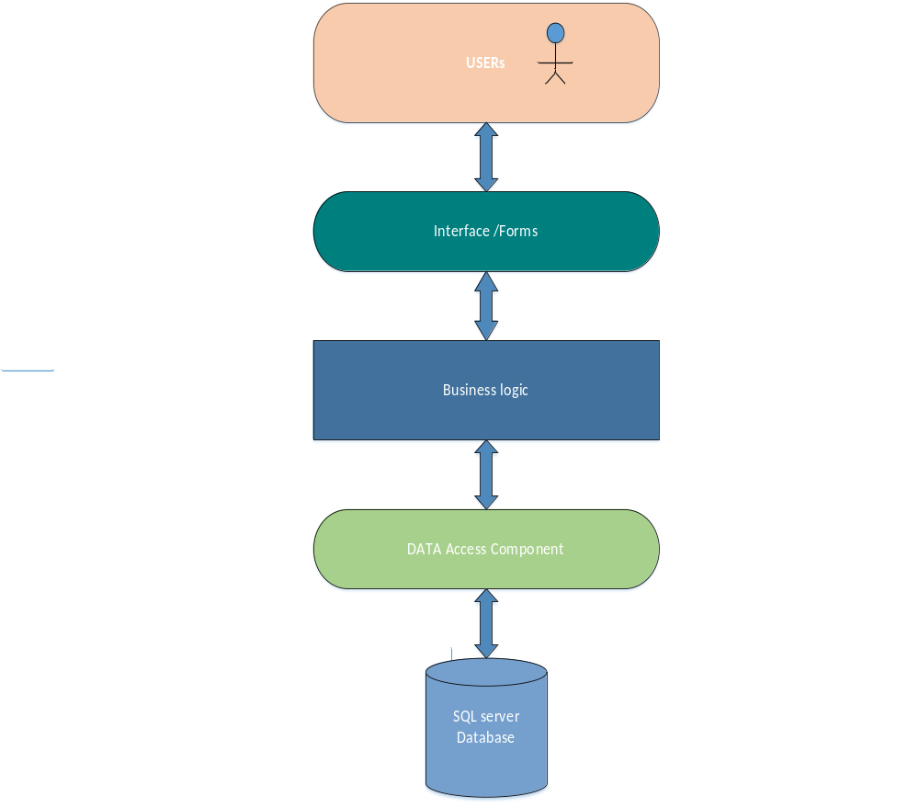

Dynamic Model: Sequence Diagrams:
Sequence diagrams are interaction diagrams that show what messages are sent and when between objects in a system. They are organized by time from top to bottom and by objects from left to right. They are used to represent all the possible interactions in a single-use case. They help to understand how a system achieves a specific goal or function.

Admin:
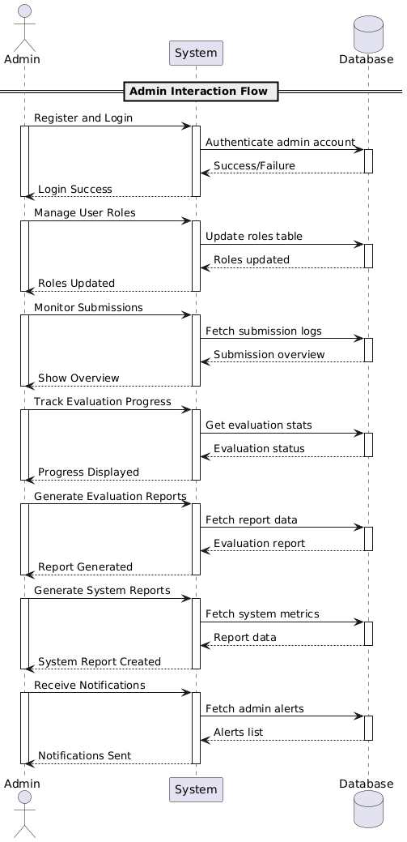
Teacher:
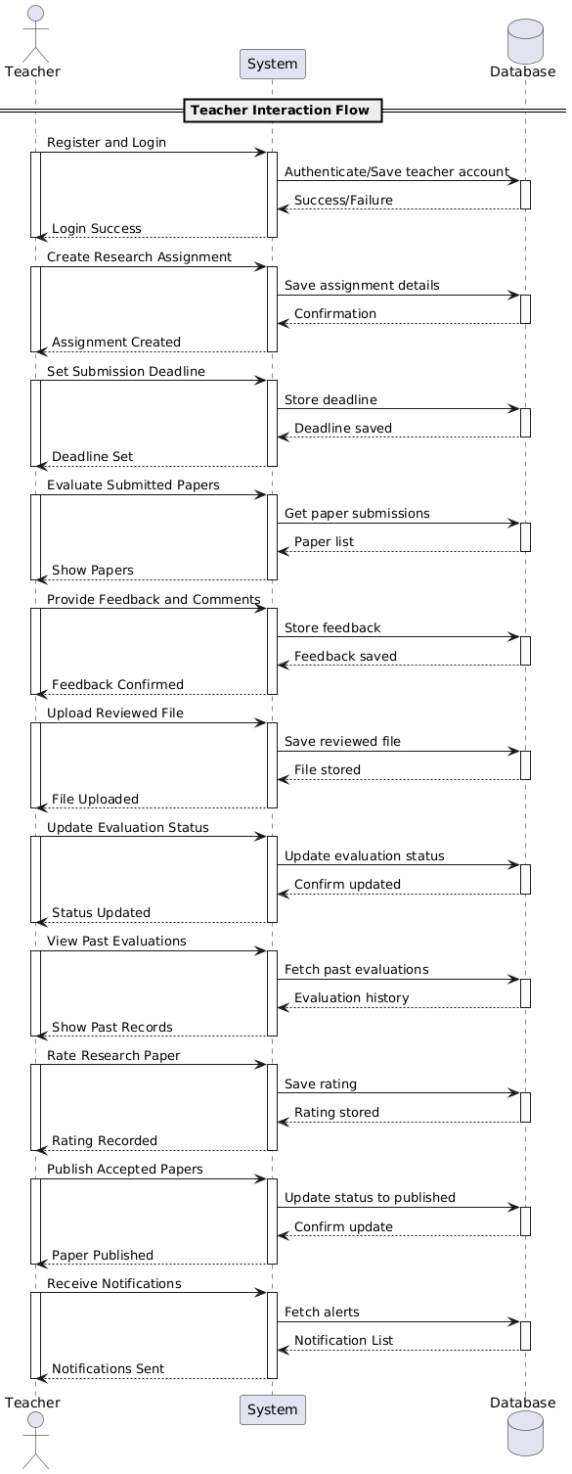
Student:
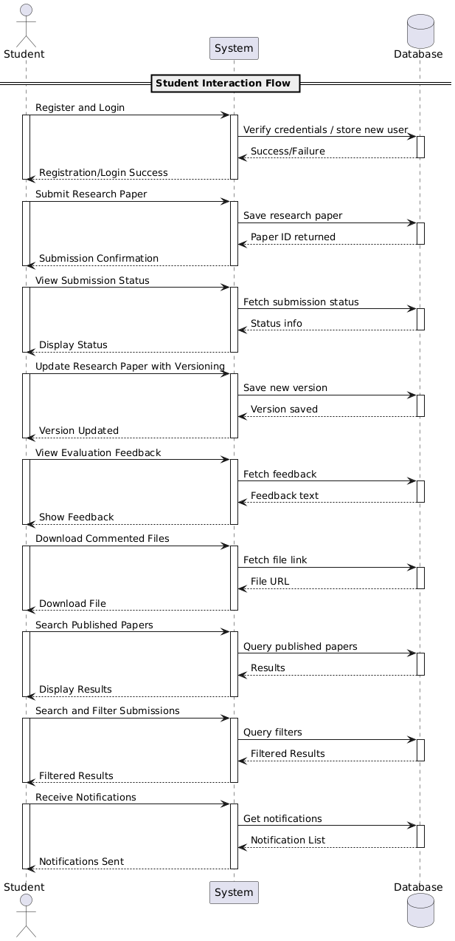

Object Model/Logical Model: Class Diagram:
A class diagram is a visual representation of the objects, attributes, and methods in a system. To create a class diagram, you need to identify the classes and their relationships, and use symbols and lines to show them.
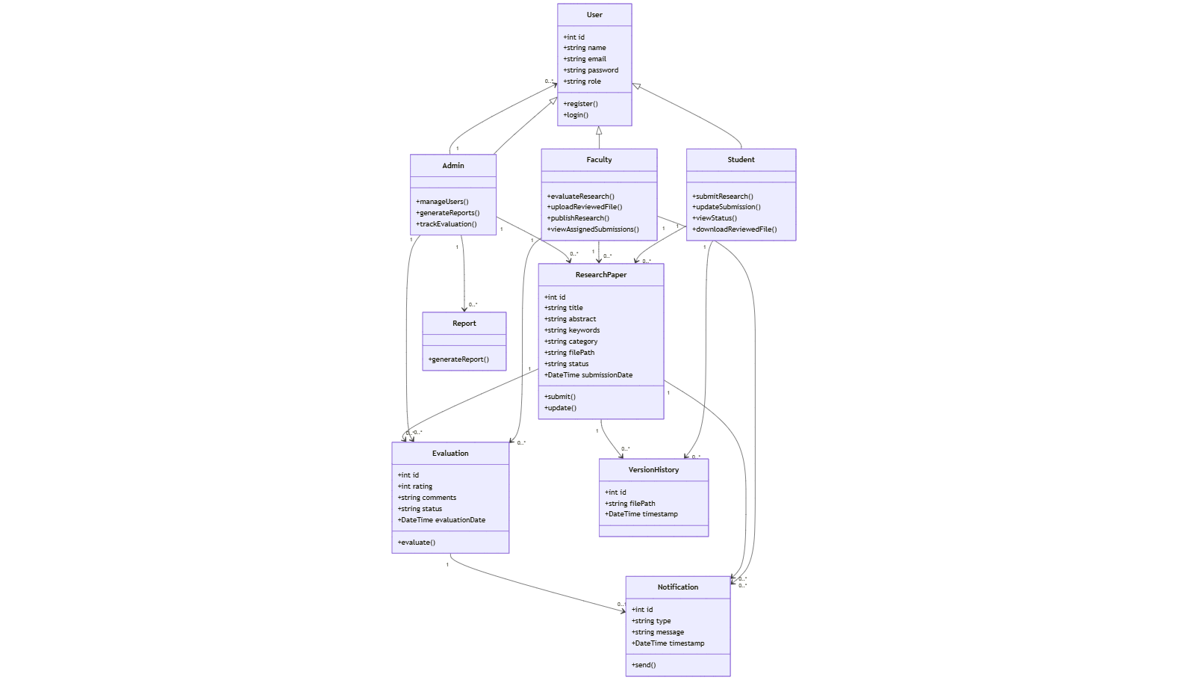

Database Model (Database Diagram):
In a database model, you define the structure of your database, including tables, columns, relationships, and constraints.
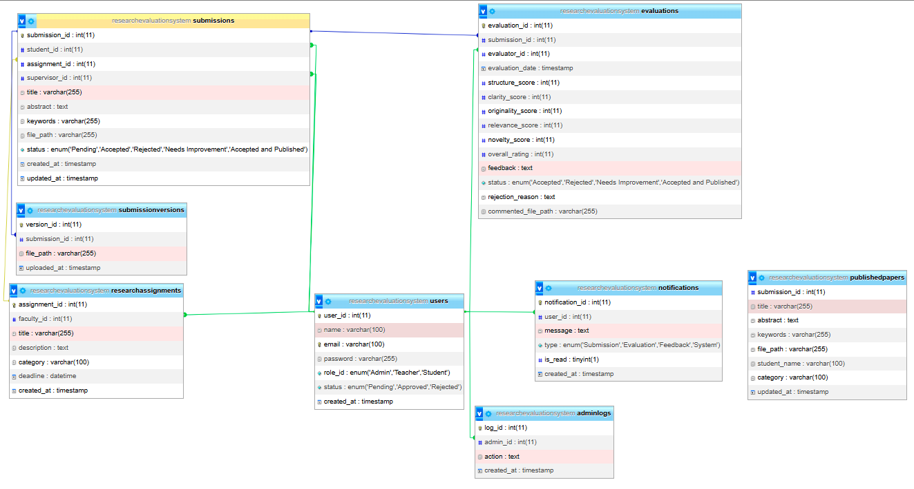

Test Case;
Test Case ID: TC001
Attribute | Student Registration
Input | Valid email and details, Duplicate email, Invalid format, Missing fields, Server down
Output | Verification email sent, Error message, Error, System error message
Expected Result | Email received + pending approval, Error for duplicate, Prompt for valid email, Flag missing fields, Notify error
Tested By | BC210409630
Test Case ID: TC002
Attribute | Faculty Registration
Input | Valid details, Duplicate entry
Output | Awaiting approval, Error message
Expected Result | Faculty added as pending, Duplicate message
Tested By | BC210409630
Test Case ID: TC003
Attribute | User Login
Input | Valid credentials, Invalid credentials, Inactive account
Output | Redirect to dashboard, Error message
Expected Result | Login success, Show "Invalid credentials", Notify inactive
Tested By | BC210409630
Test Case ID: TC004
Attribute | Role-Based Access
Input | Login as faculty/admin
Output | Role dashboard
Expected Result | Show relevant dashboard
Tested By | BC210409630
Test Case ID: TC005
Attribute | Submit Research Paper
Input | Valid file + metadata, Late submission
Output | Confirmation, Email sent, Error message
Expected Result | Paper submitted, Block late submission
Tested By | BC210409630
Test Case ID: TC006
Attribute | Evaluate Research Paper
Input | Valid review input, Missing rating
Output | Evaluation saved, Error message
Expected Result | Evaluation complete, Prompt to fill missing rating
Tested By | BC210409630
Test Case ID: TC007
Attribute | Upload Reviewed Document
Input | Valid reviewed file
Output | Upload confirmation
Expected Result | Reviewed file uploaded
Tested By | BC210409630
Test Case ID: TC008
Attribute | Publish Research Paper
Input | Accepted paper, Unaccepted paper
Output | Status set to Published, Error message
Expected Result | Only accepted papers published, Prevent publishing
Tested By | BC210409630
Test Case ID: TC009
Attribute | Update Submission
Input | Valid new version, Invalid file
Output | Confirmation, Old version saved, Error message
Expected Result | Previous version logged, Invalid format blocked
Tested By | BC210409630
Test Case ID: TC010
Attribute | Email Notifications
Input | Trigger event (e.g., submission or evaluation)
Output | Email sent
Expected Result | User receives correct email
Tested By | BC210409630
Test Case ID: TC011
Attribute | Search Submissions
Input | Valid keywords, No matching filters
Output | Filtered results, No results message
Expected Result | Results matching filters shown, "No results" message
Tested By | BC210409630
Test Case ID: TC012
Attribute | Generate Reports
Input | Valid filters and report type, Unauthorized access
Output | Downloadable report, Error message
Expected Result | Report is generated, Access blocked for unauthorized
Tested By | BC210409630
Test Case ID: TC013
Attribute | Admin Panel Access
Input | Admin login, Unauthorized login
Output | Admin dashboard, Access denied
Expected Result | Admin manages system, Access denied
Tested By | BC210409630
Test Case ID: TC014
Attribute | Track Evaluation Progress
Input | Login as admin/faculty
Output | Evaluation statuses, Reminders sent
Expected Result | Progress visible, Reminders work
Tested By | BC210409630
Test Case ID: TC015
Attribute | Download Reviewed Files
Input | Reviewed file available, No file available
Output | File downloaded, Error message
Expected Result | Student can download file, Show message if no file
Tested By | BC210409630

Graphical User Interfaces:

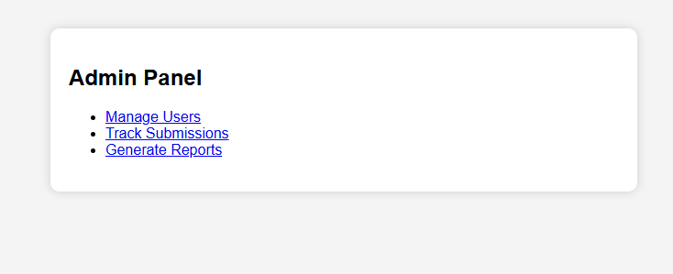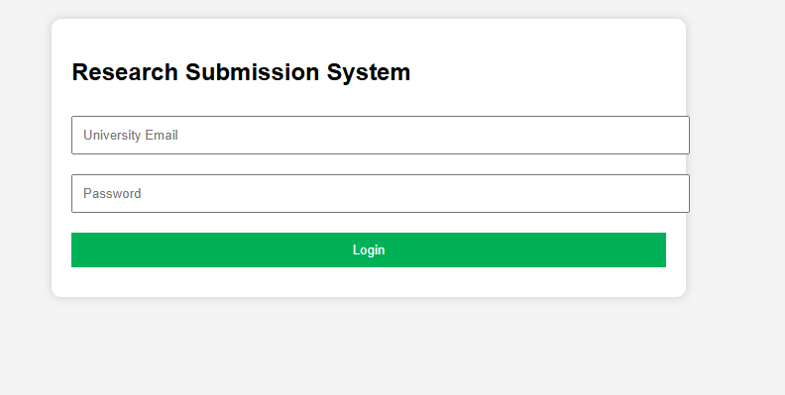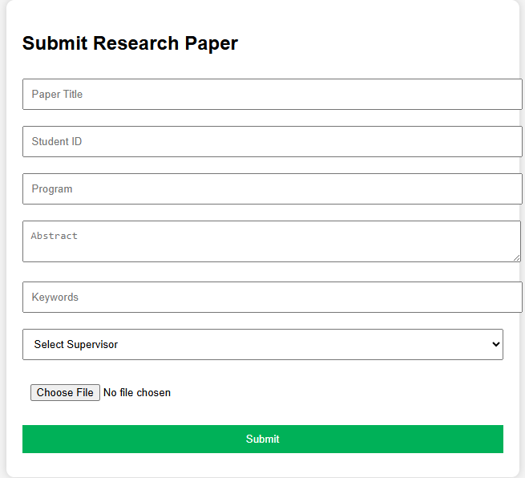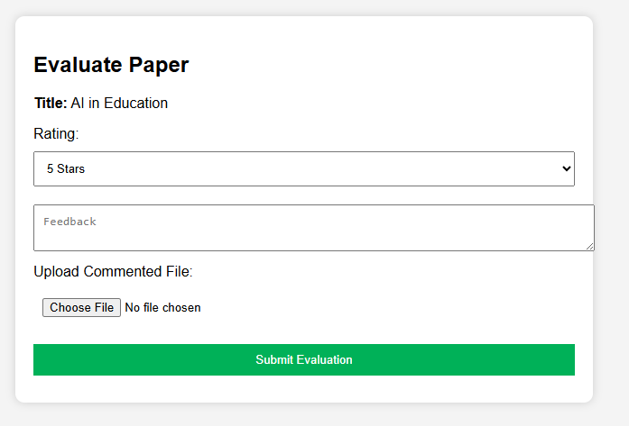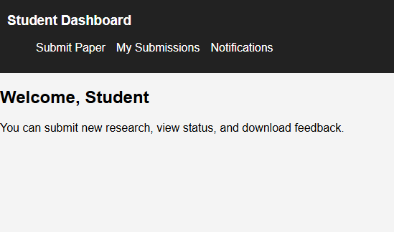

Chapter 3

Development

REFERENCES

Handouts CS504 – Software Engineering – I
Handouts CS5605 – Software Engineering – II
Handouts C403 – DMBS

APPENDIX

Section 1 | Gathering & Analyzing Info
Section 2 | Designing the Project
Section 3 | Development

